**FSM**

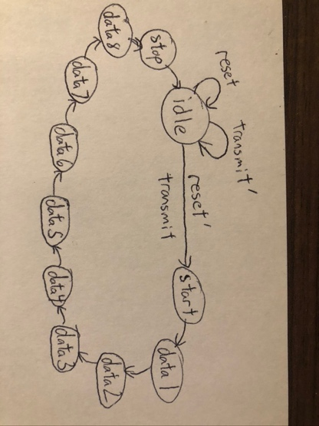

**ASM**

**Manch_encoder**

library IEEE;

use IEEE.STD_LOGIC_1164.ALL;

use IEEE.NUMERIC_STD.ALL;

entity manch_encoder is

Port ( str_input : in STD_LOGIC_VECTOR (7 downto 0);

clk : in STD_LOGIC;

reset : in STD_LOGIC;

transmit : in STD_LOGIC;

str_output : out STD_LOGIC);

end manch_encoder;

architecture Behavioral of manch_encoder is

type statetype is (idle, start, data1, data2, data3, data4, data5, data6, data7, data8, stop);

signal state_reg, state_next : statetype;

signal str_output_next, str_output_reg : std_logic := '0';

signal data_reg : std_logic_vector(7 downto 0);

begin

--state_reg

process(clk, reset, transmit) is

begin

if(transmit = '1') then

data_reg <= str_input;

end if;

if(reset = '1') then

state_reg <= idle;

data_reg <= "00000000";

elsif(clk'event and clk = '1') then

state_reg <= state_next;

end if;

end process;

--Next state logic

process(state_reg, transmit)

begin

case(state_reg) is

when idle =>

if(transmit = '1') then

state_next <= start;

else

state_next <= idle;

end if;

when start => state_next <= data1;

when data1 => state_next <= data2;

when data2 => state_next <= data3;

when data3 => state_next <= data4;

when data4 => state_next <= data5;

when data5 => state_next <= data6;

when data6 => state_next <= data7;

when data7 => state_next <= data8;

when data8 => state_next <= stop;

when stop => state_next <= idle;

end case;

end process;

process(state_next)

begin

str_output_next <= '0';

case(state_next) is

when idle => str_output_next <= '0';

when start => str_output_next <= '0';

when data1 => str_output_next <= data_reg(7);

when data2 => str_output_next <= data_reg(6);

when data3 => str_output_next <= data_reg(5);

when data4 => str_output_next <= data_reg(4);

when data5 => str_output_next <= data_reg(3);

when data6 => str_output_next <= data_reg(2);

when data7 => str_output_next <= data_reg(1);

when data8 => str_output_next <= data_reg(0);

when stop => str_output_next <= '0';

end case;

end process;

process(clk, reset, str_output_next)

begin

if(reset = '1') then

str_output_reg <= '0';

elsif (clk'event and clk = '1') then

str_output_reg <= str_output_next;

end if;

end process;

process(clk, state_reg)

begin

if(state_reg = idle or state_reg = start or state_reg = stop) then

str_output <= '0';

else

str_output <= str_output_reg xnor clk;

end if;

end process;

end Behavioral;

Manch_encoder_tb

library IEEE;

use IEEE.STD_LOGIC_1164.ALL;

entity manch_encoder_tb is

end manch_encoder_tb;

architecture Behavioral of manch_encoder_tb is

signal d_in : std_logic_vector(7 downto 0);

signal clk, reset, d_out : std_logic;

signal t : std_logic := '1';

begin

p0 : entity work.manch_encoder(behavioral) port map(d_in, clk, reset, t, d_out);

d_in <= "10011011";

--t <= '1';

process is

begin

reset <= '0';

clk <= '1';

wait for 50ns;

clk <= '0';

t <= '0';

wait for 50ns;

end process;

end Behavioral;

